How to create a user define function.

Step 1 Open a test

Step 2 Go to file🡪 new-🡪function library.

i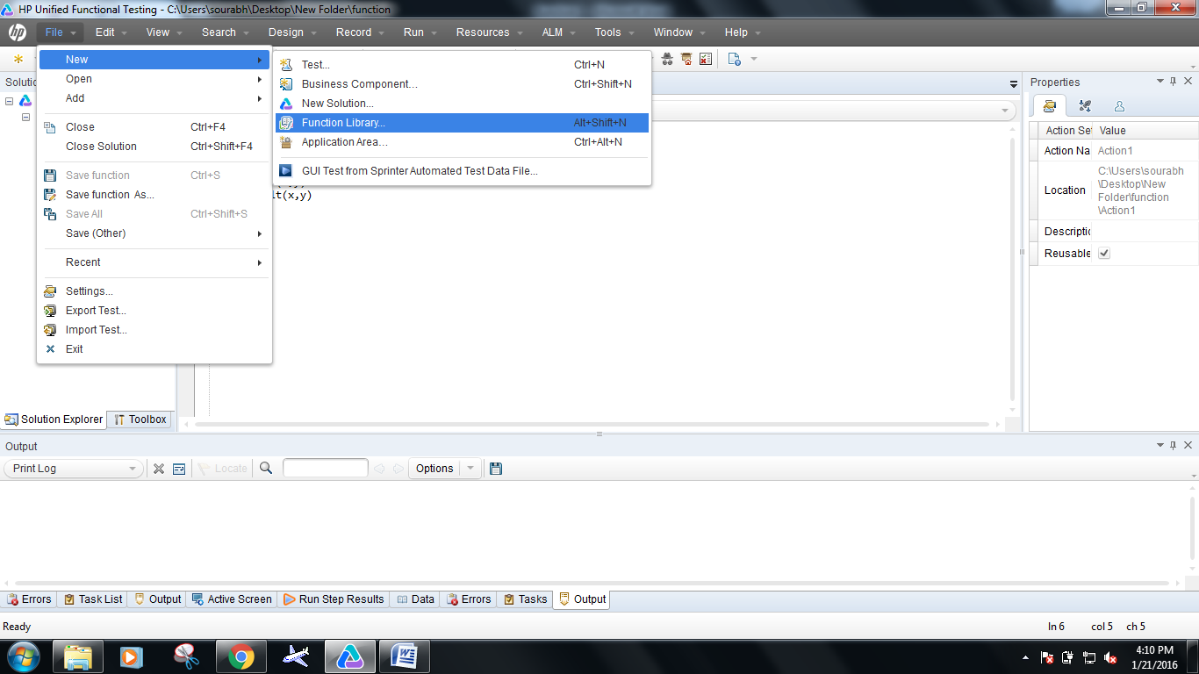

Step 3 Open a window from where you can save function name.

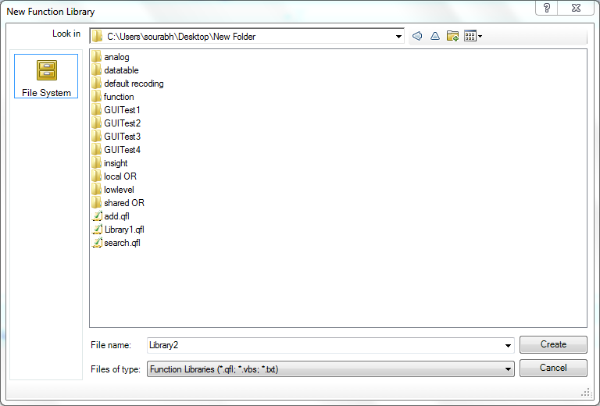

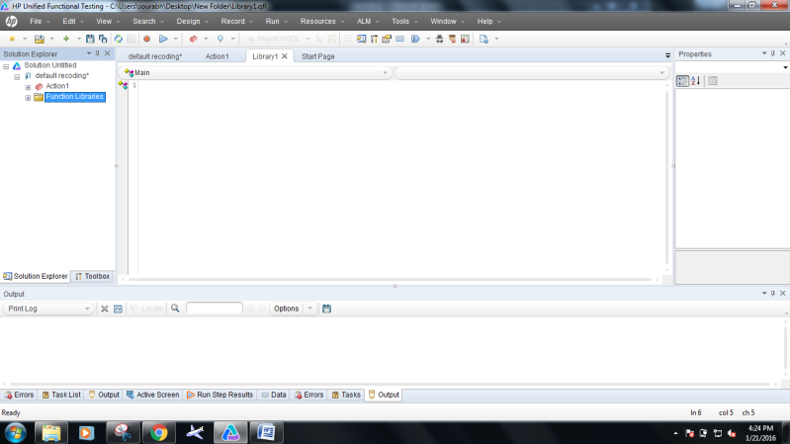

How to associate the libraries in the test.

Step 1 Now click on file menu🡪setting🡪resource. Click on add associate libraries.

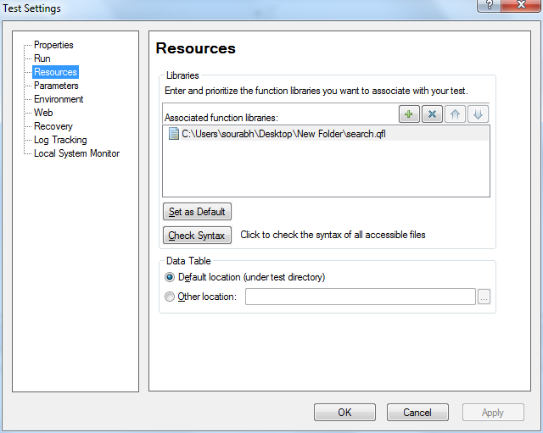

Step 2 A window is open from where you can select which function you want to add.

Step 3 Click on solution exproler click on function libriries then you see then function

